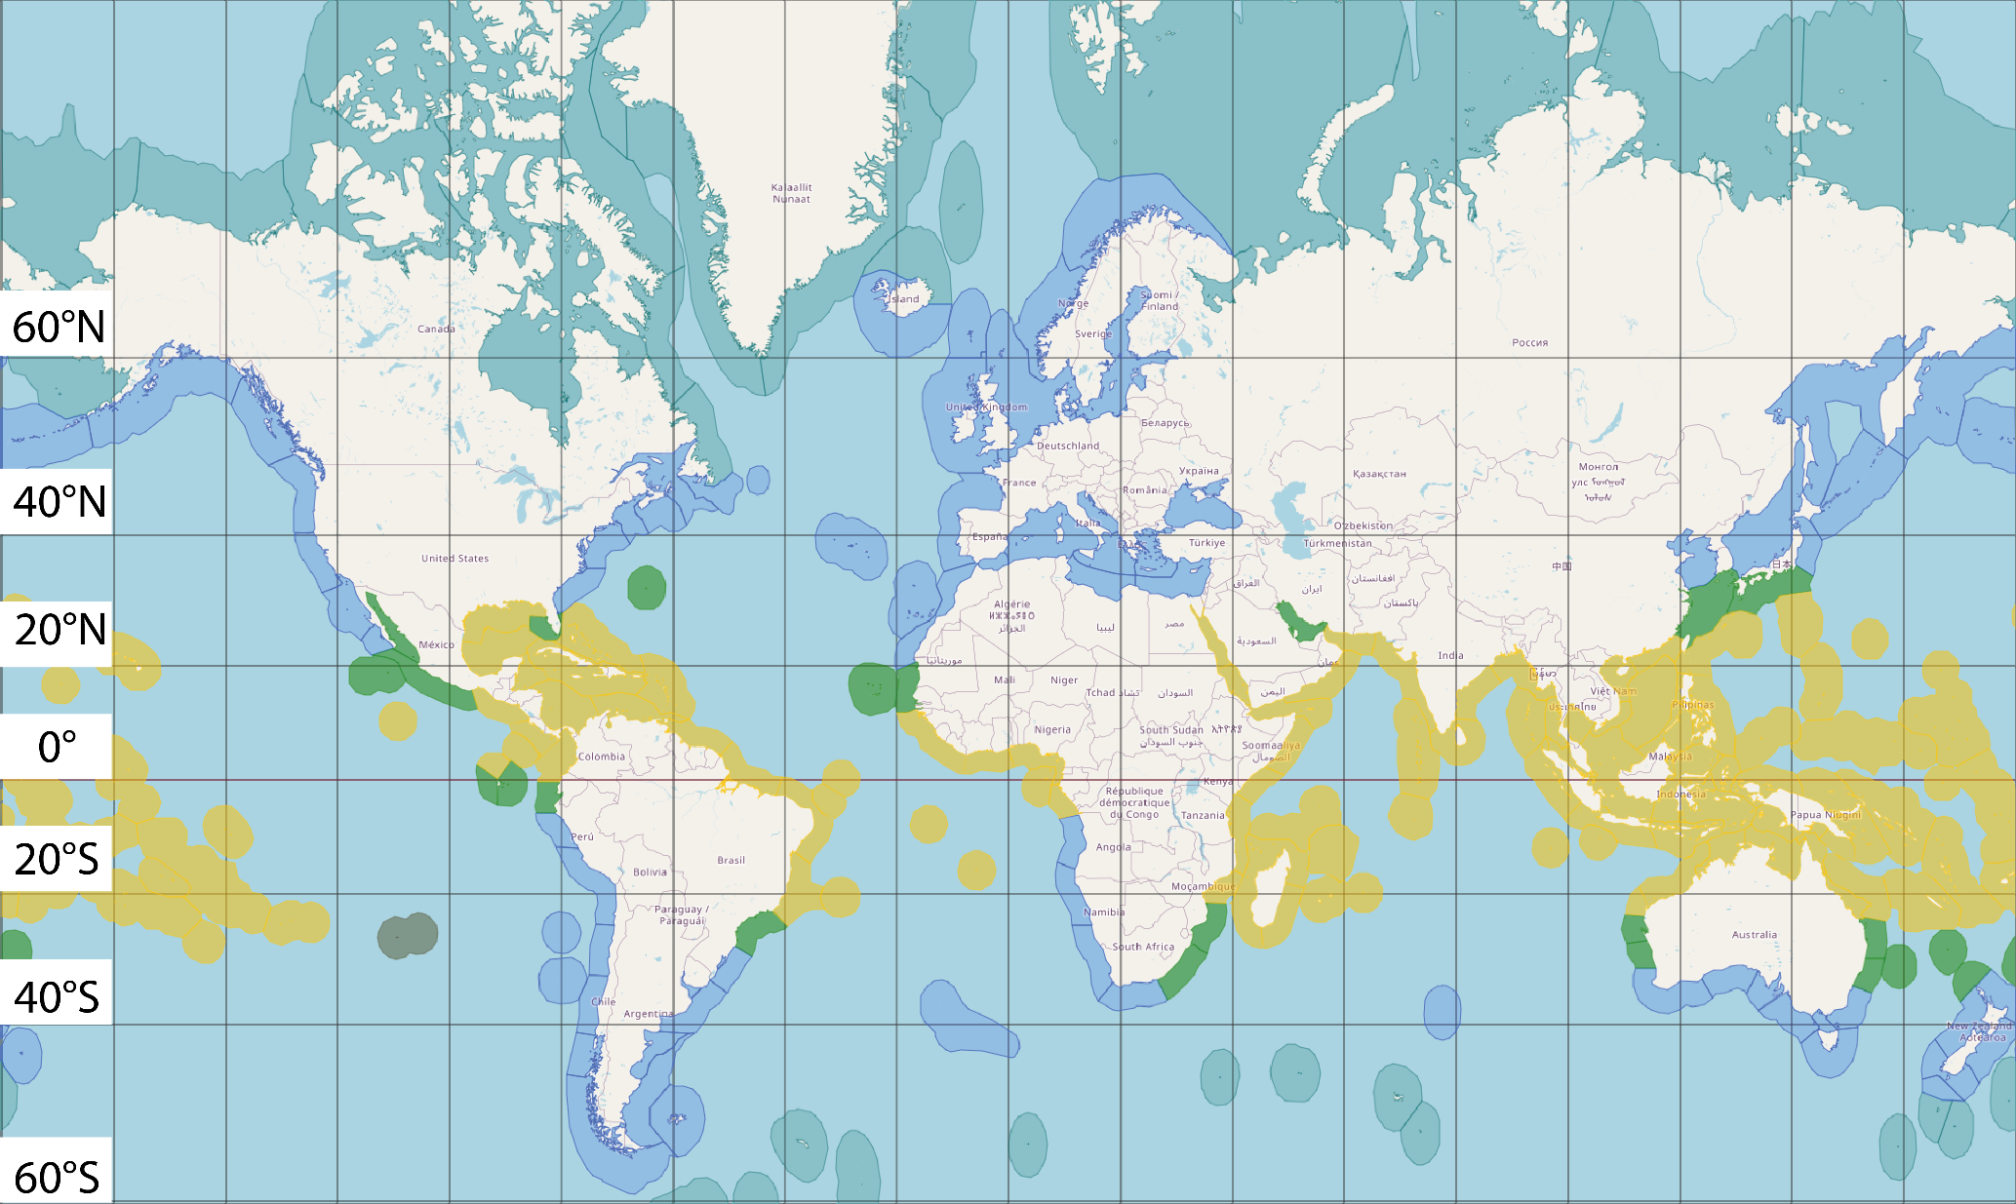

Figure 2 Map showing tropical ecoregions (Yellow), subtropical ecoregions (Green), temperate ecoregions (Blue) and arctic ecoregions (Light Blue). The grey area between 20°S and 40°S to the left side of the figure is the Easter Island, where both tropical and subtropical ecoregions can be found (20, 29).